**NIT3222** **–** **Virtualisation** **in** **Computing** **Lab** **3**

***ID: s4650134 Name: _FangSen(Wirth)___ _________***

This lab will use software found in ‘C:\Lab Software-2012\MAP\Latest\’ .

**1)** **Mounting** **a** **VHDX**

- Start Server from Azure Dashboard

- Open Hyper-V server

- Start VM with windows Server 2012 installed in Lab 1

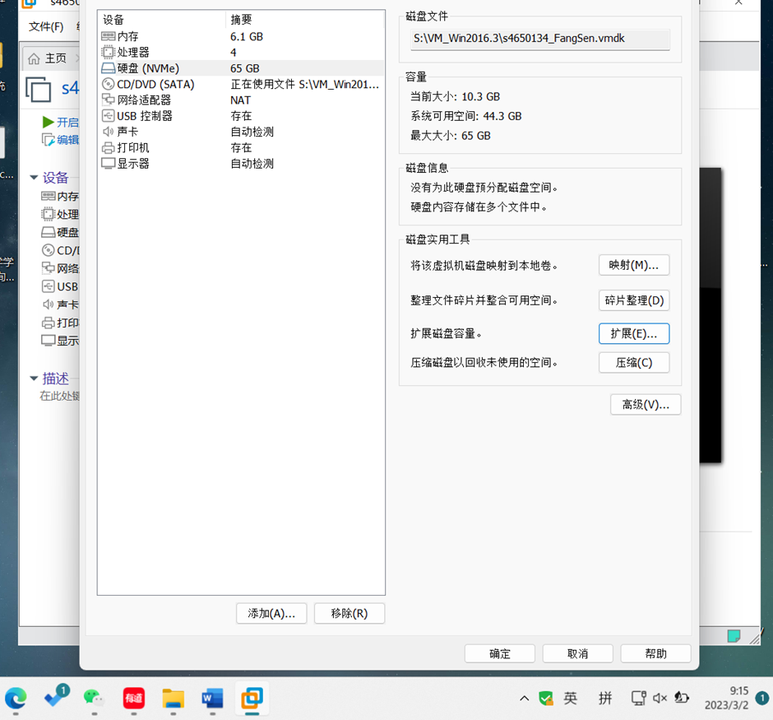

- Open VM settings, create new VHDX with your student id

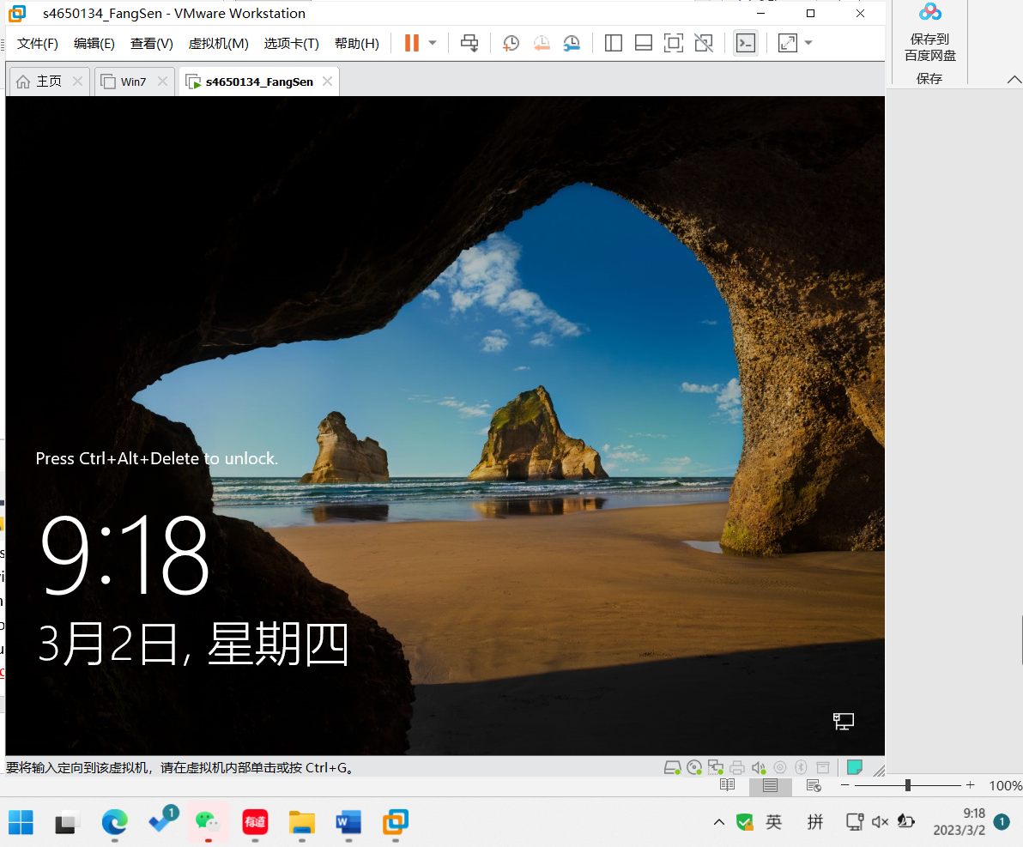

- Login to windows Server 2012

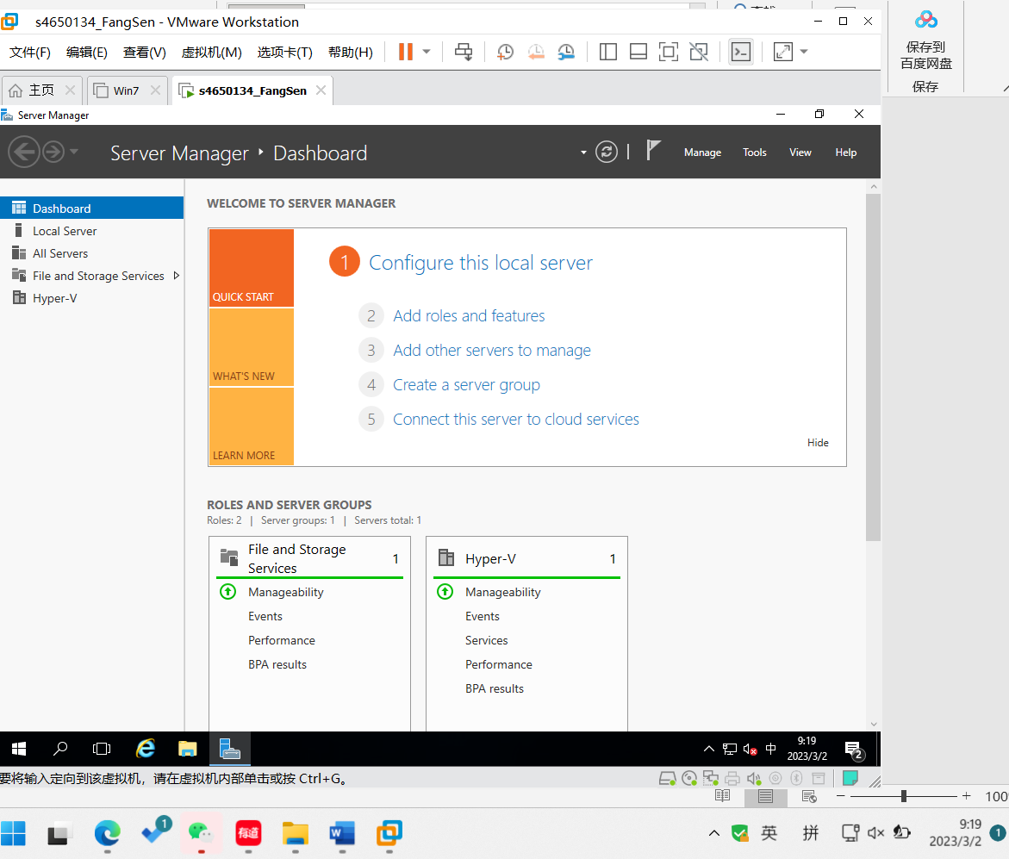

- Using Computer Management to format you created VHDX with Label E:

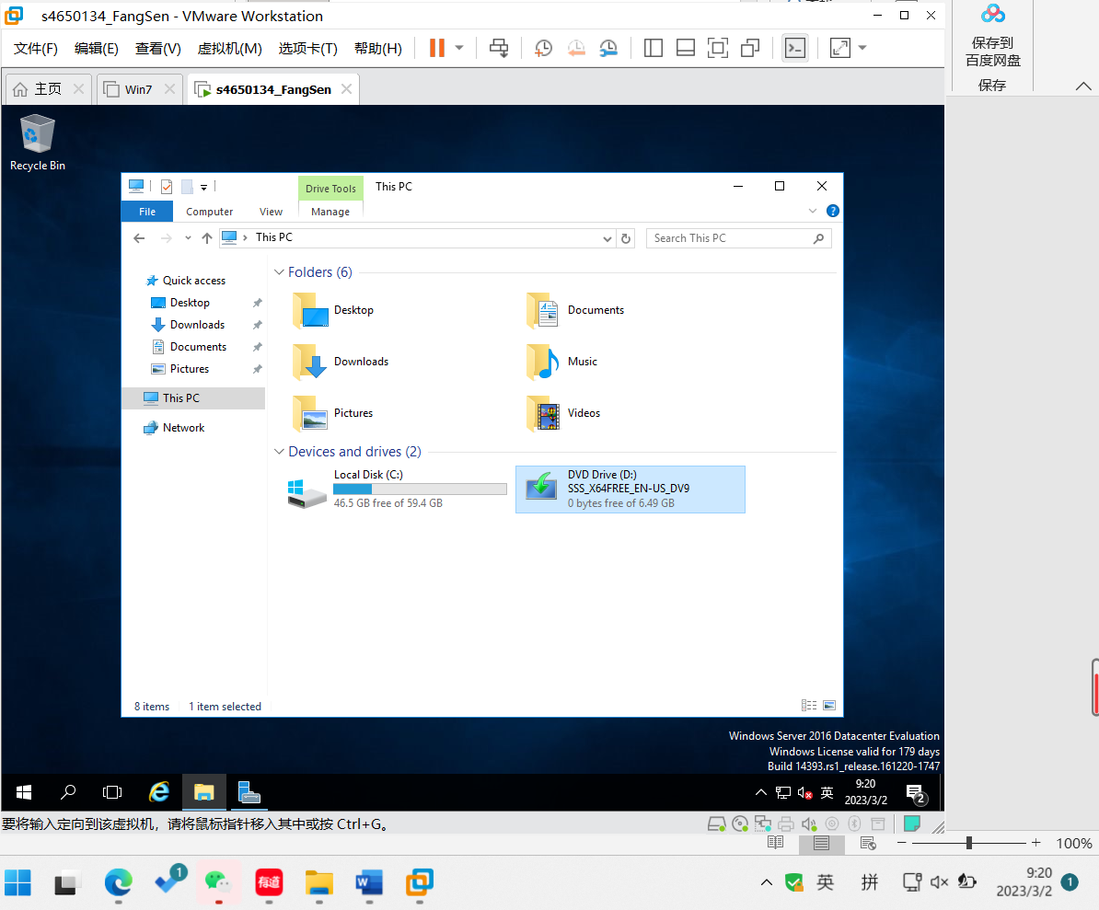

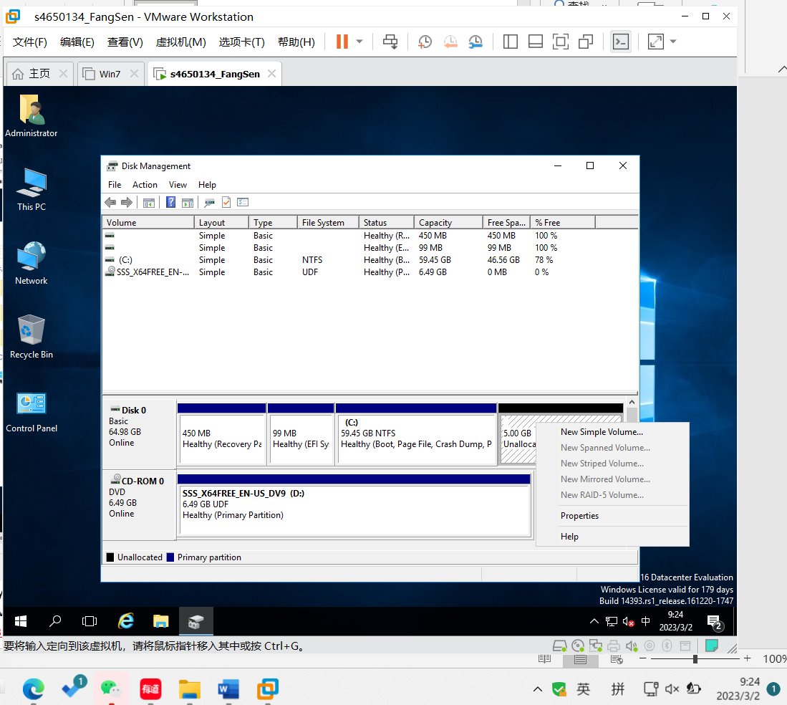

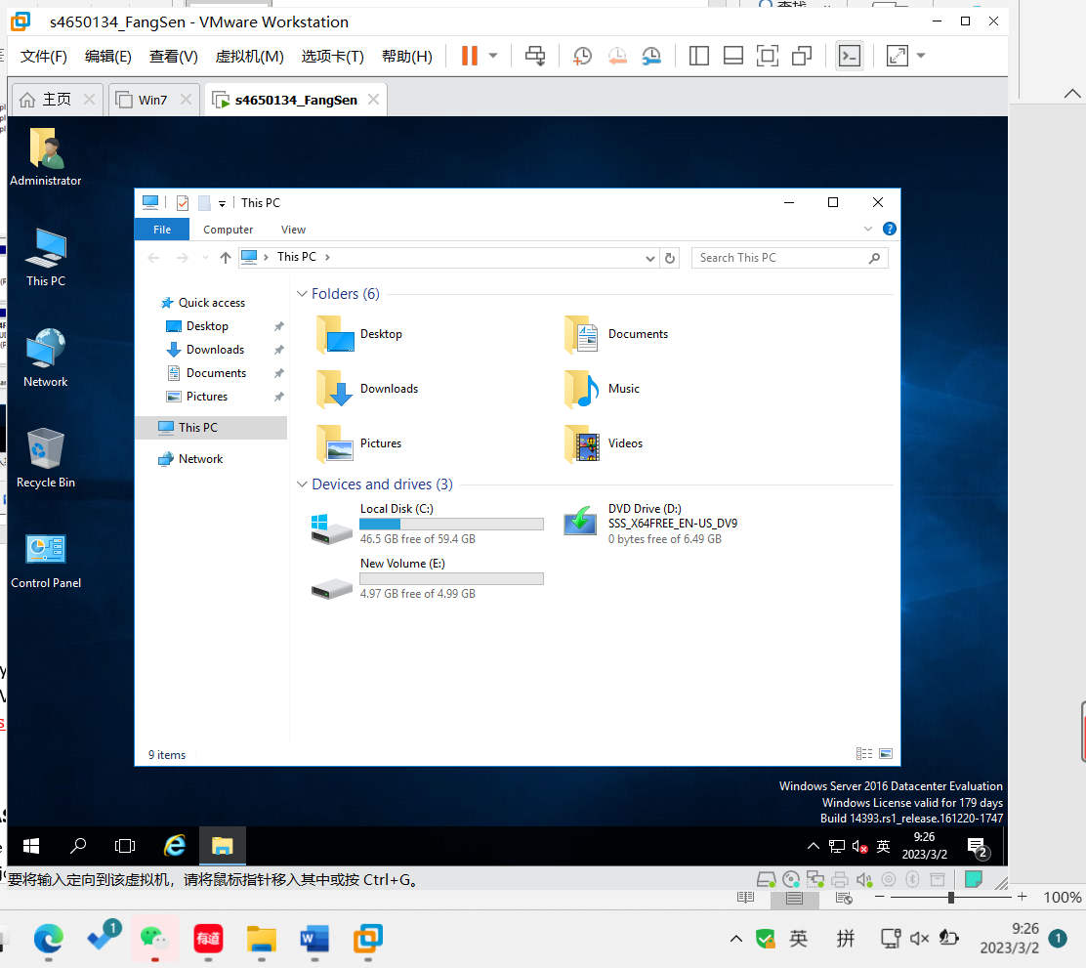

- Create a folder with your student id as name, record screen with created folder.

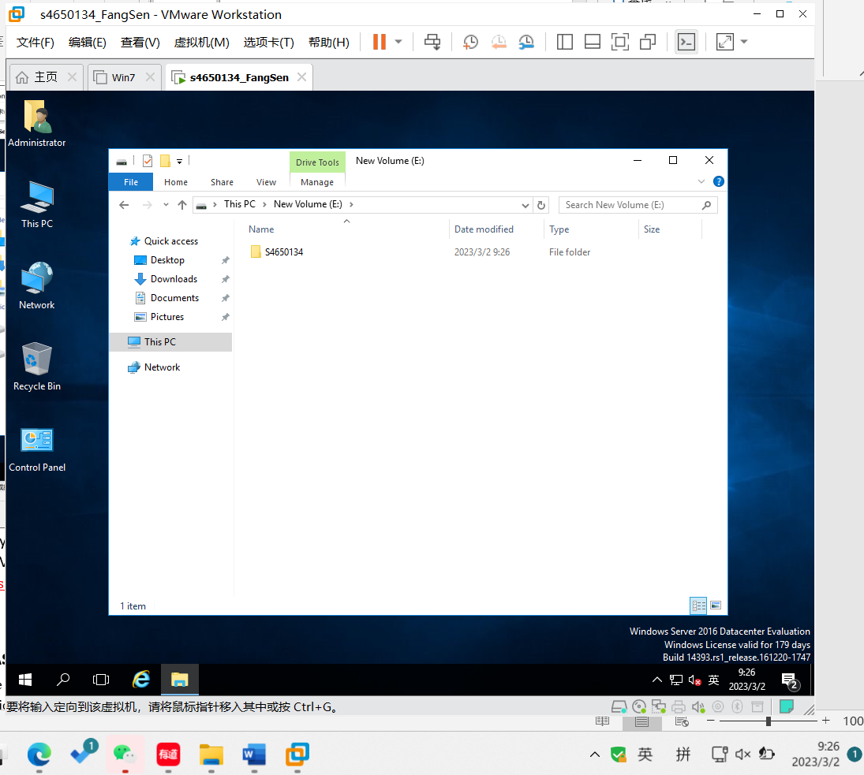

- Delete your created VHDX from VM, record screen from Computer Management.

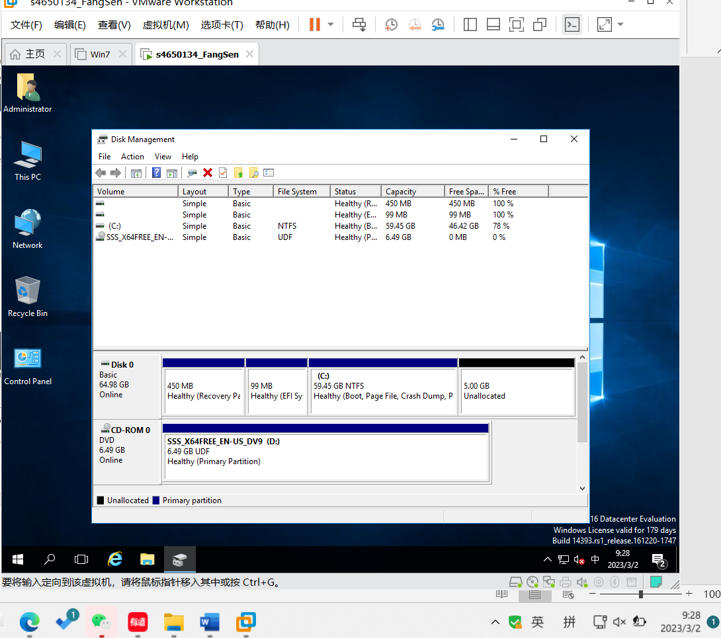

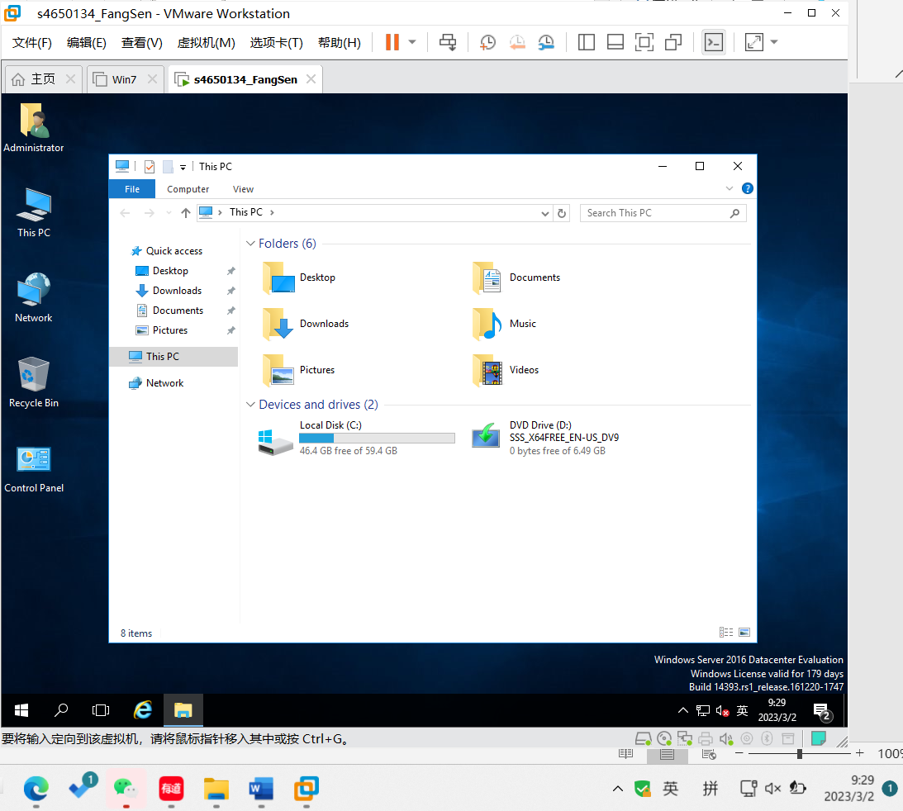

Note that, show your records to your tutor.

**2)** **Install** **Microsoft** **Assessment** **and** **Planning** **Toolkit** **(MAP)**

After installing the prerequisite software you can install the MAP toolkit using ‘MapSetup.exe’ . When prompted select not to join the Customer Experience Improvement Program.

**3)** **Run** **the** **Microsoft** **Assessment** **and** **Planning** **Toolkit**

**1.** **Launch** **the** **Microsoft** **Assessment** **and** **Planning** **Toolkit**

Create a new “INVENTORY” database on first run.

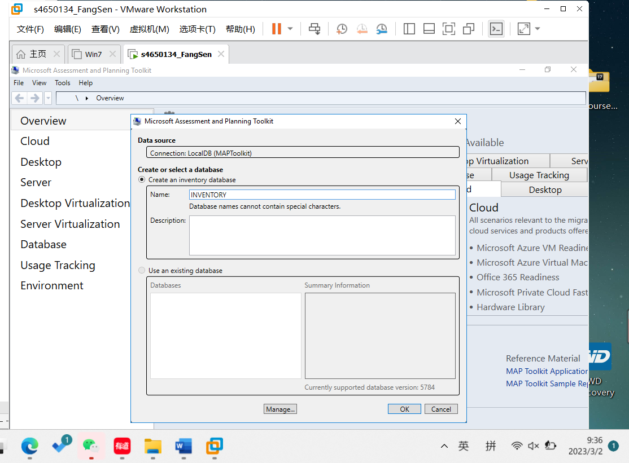

**2.** **Profile** **the** **current** **server**

Before performing an inventory, create a file called “names.txt” in the documents folder that contains the name of the current server.

1. On the main screen click “Perform an inventory”

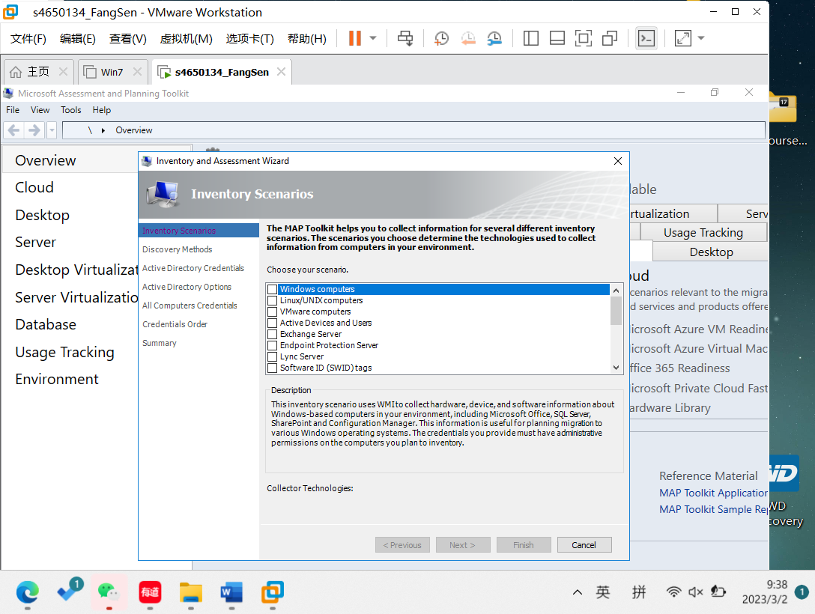

1. Select “Windows Computers” and click Next

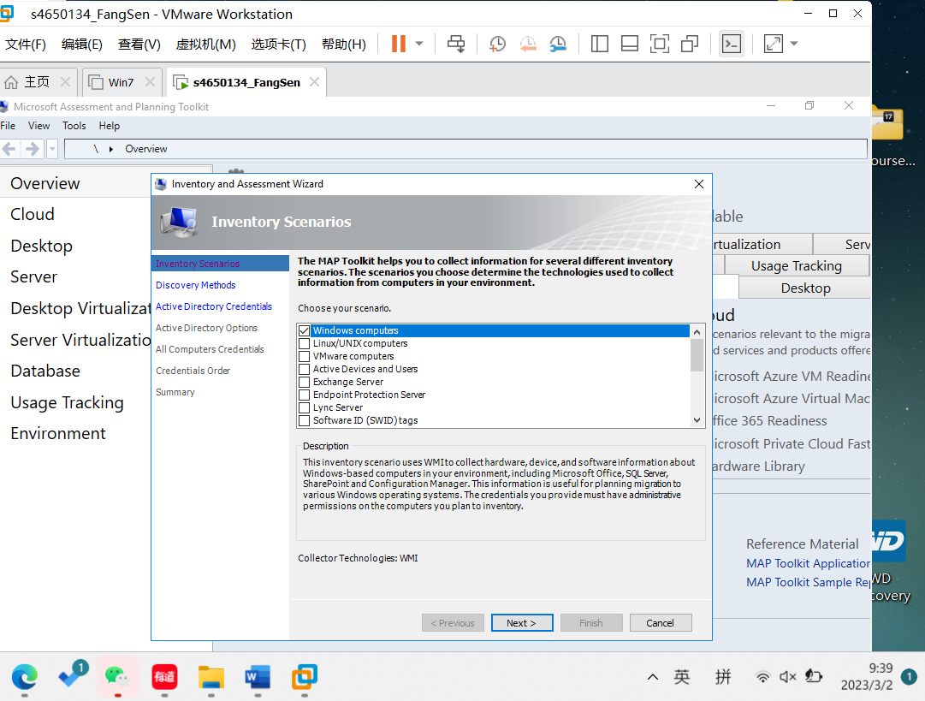

1. Deselect “Use ActiveDirectory Domain Services”

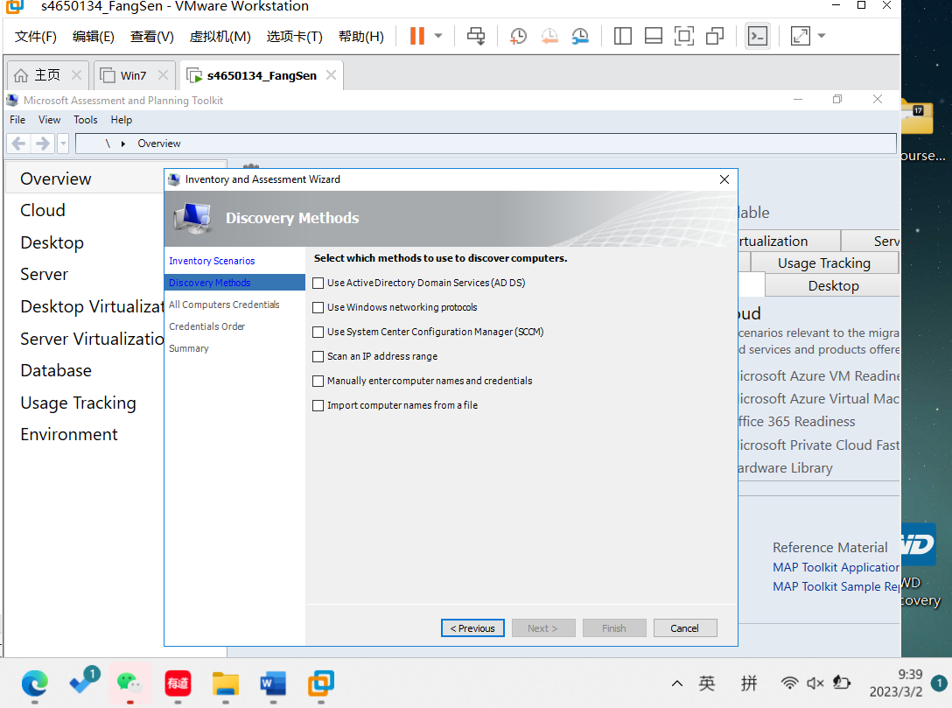

1. Select “Import computer names from a file”

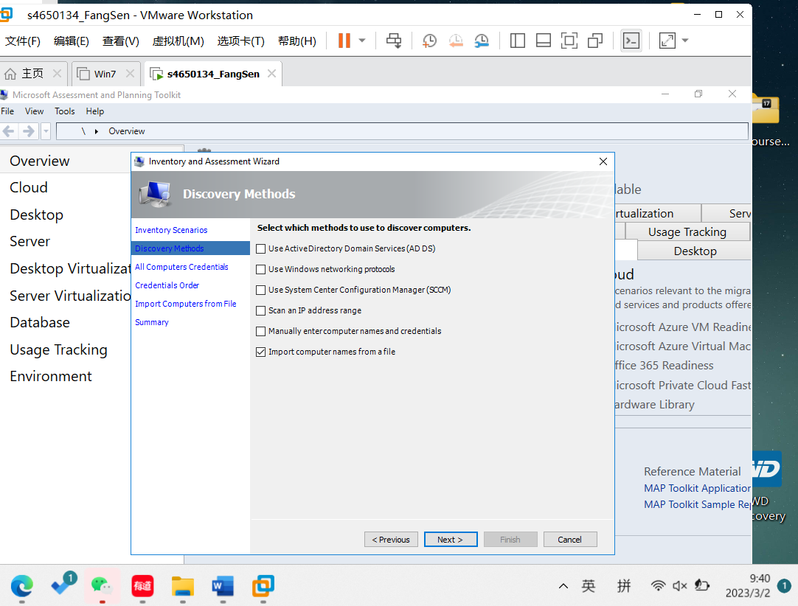

1. Add the current administrator account to “All Computers Credentials”

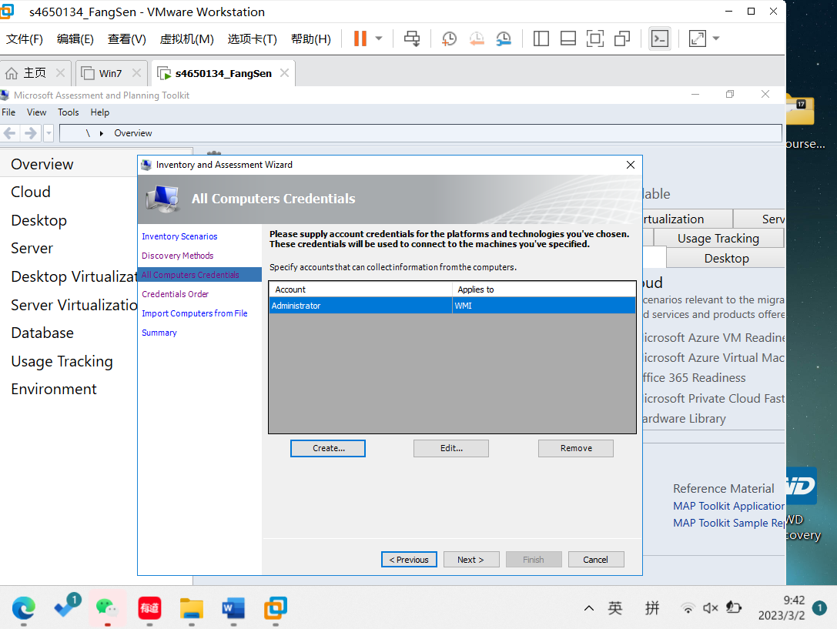

1. 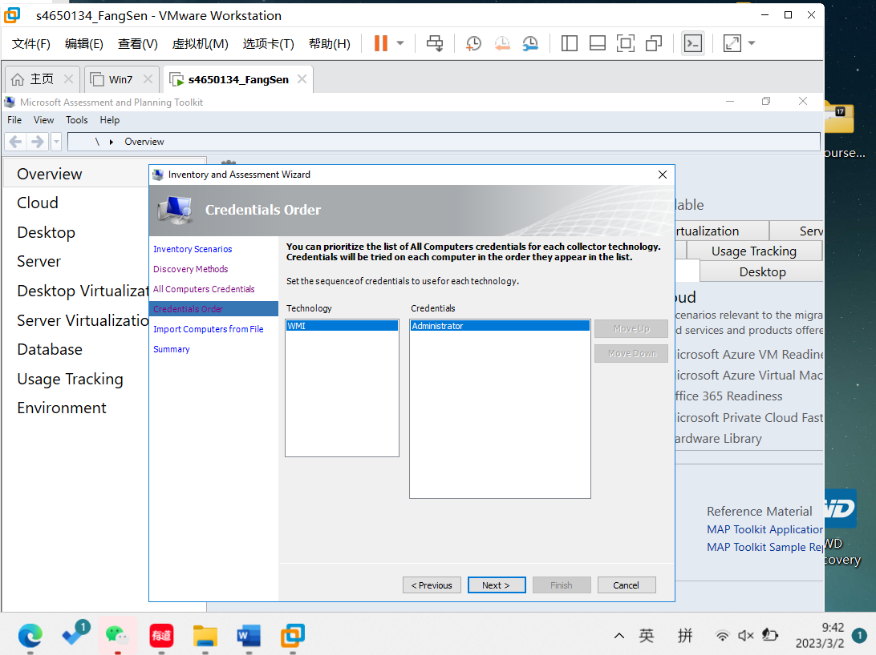Click Next on “Credentials Order”
2. Add “names.txt” to “Import Computer from File” . Select “Use All Computers credential list”

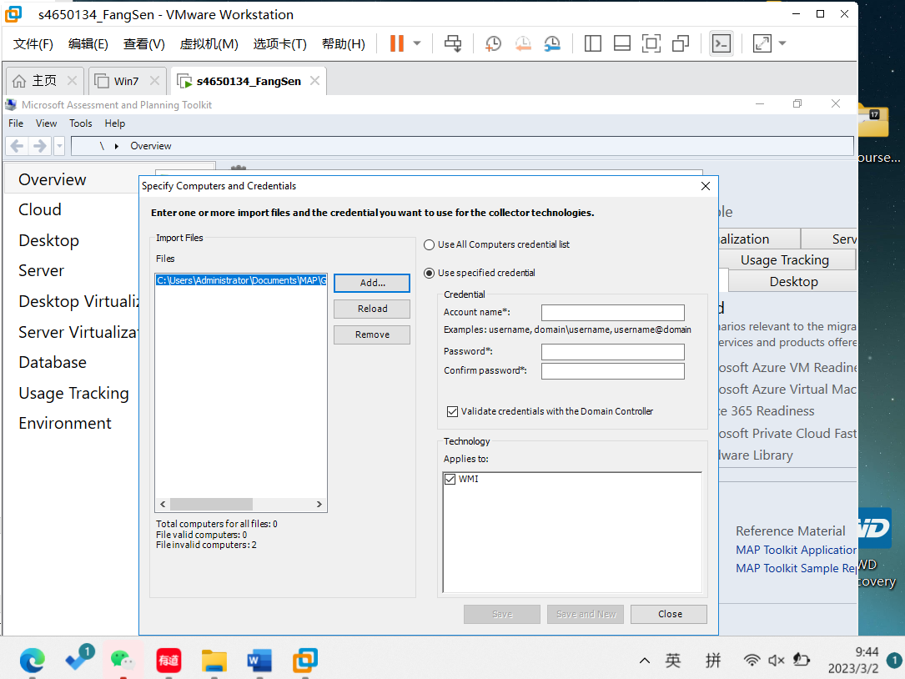

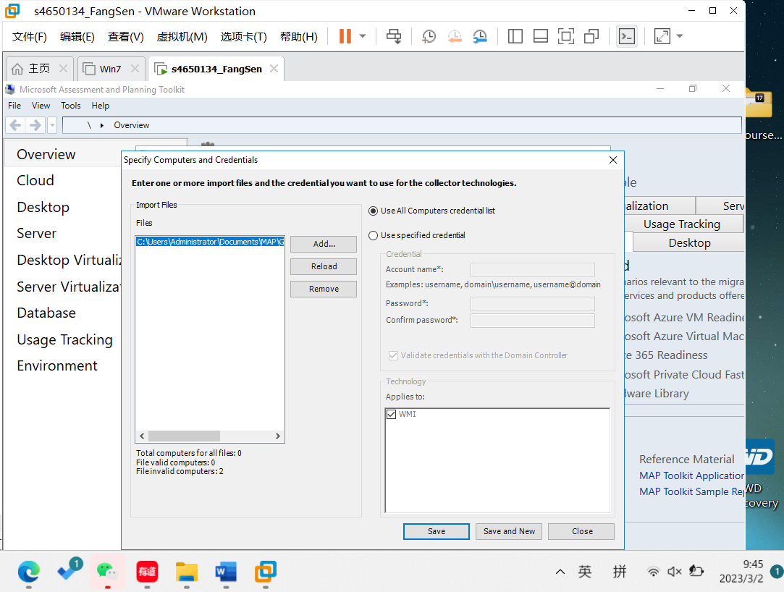

8. Click Finish

**3.** **Collect** **performance** **data** **about** **the** **current** **server**

Go to the “Desktop Virtualisation” section and click Collect performance data.

1. Select Windows-based machines

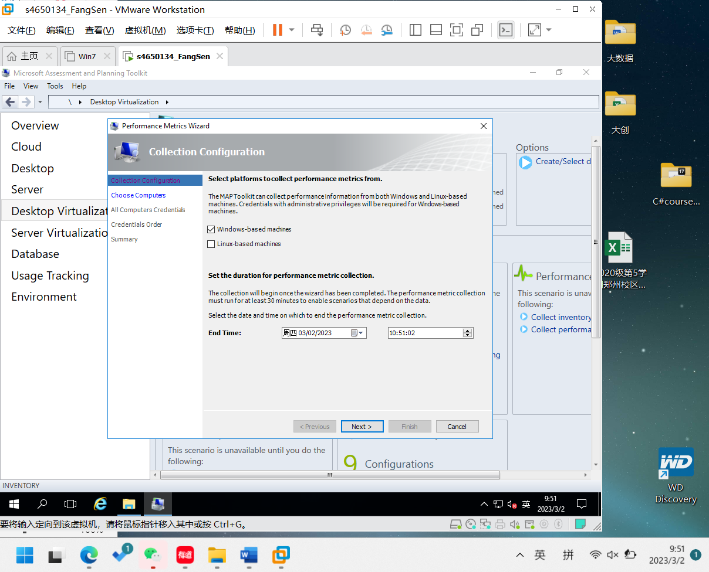

1. Set the time for 30 minutes from the current time

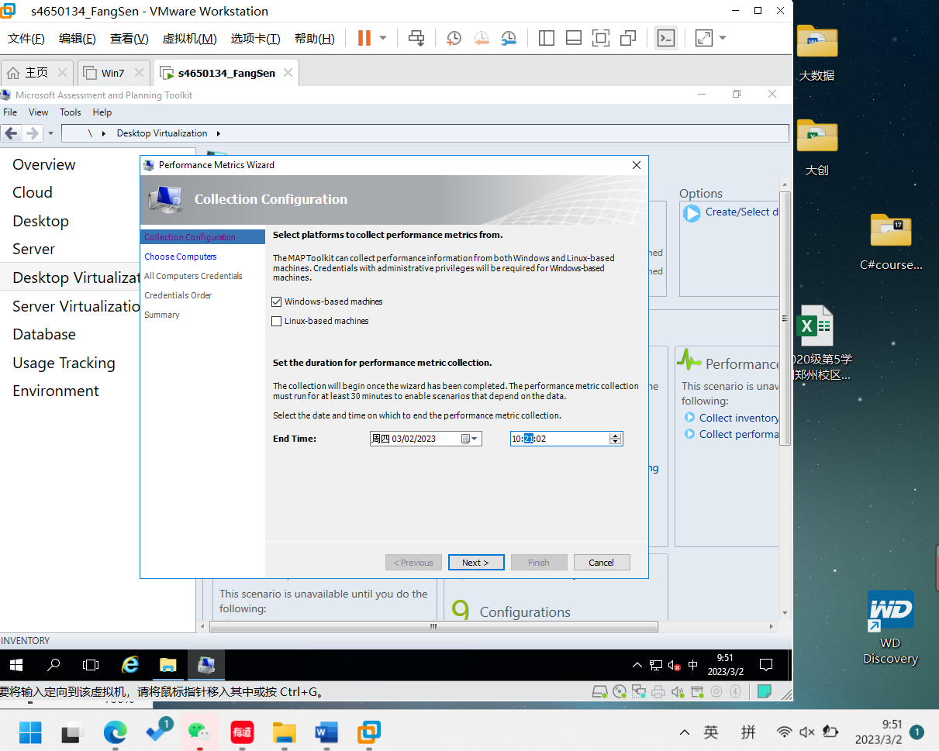

3. Select “Choose the computers from a list on the next step of the wizard”

4. Select the current machine

5. Complete the wizard and click Finish

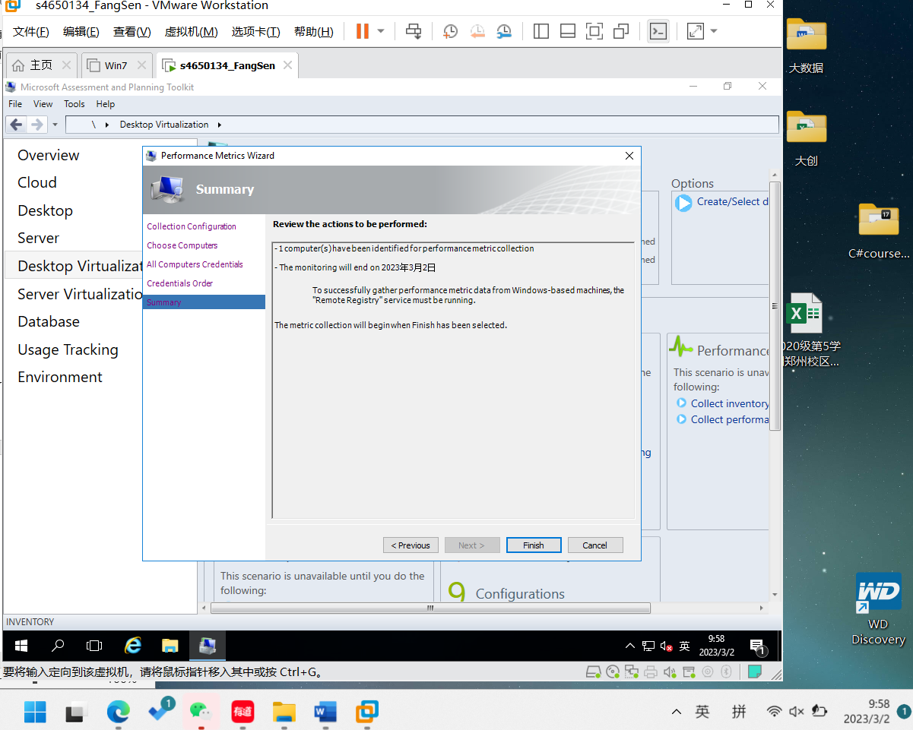

Upon completion, demonstrate to the lecturer you have successfully captured data.

